**Aim:** To transmit and receive digital signal using Frequency Shift Keying. **Apparatus:** Scientech ST2156 and ST2157trainer kit, DSO/CRO, CRO Probes, Connecting Probes **Theory:**

In frequency shift keying, the carrier

frequency is shifted in steps (i.e. from one

frequency to another)

corresponding to the digital modulation signal. If the higher frequency is used to represent data '1' & lower frequency for data '0', the resulting Frequency shift keying waveform appears as shown in figure 1.ThusData = 1 high frequency,Data = 0 low frequency

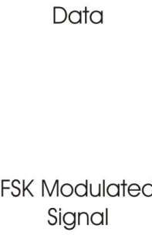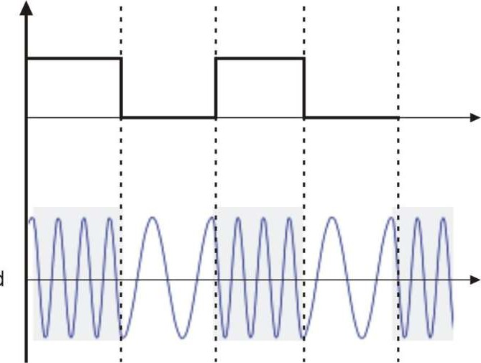

Figure 1. Frequency Shift Keying modulation waveform

On a closer look at the FSK waveform, it is apparent that it can be represented waveforms. This is illustrated in figure 3.

as the sum oftwo ASK

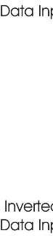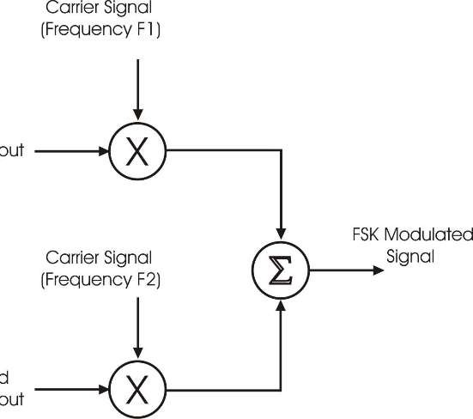

Figure 2. Frequency Shift Keying Modulator

The functional blocks required in order to generate the FSK signal is as shown in figure 2. There are two ASK modulator, each has different carrier frequencies but the digital data is inverted in one of the modulator. These two different ASK modulated signal are applied to the summing amplifier to get FSK modulated signal.

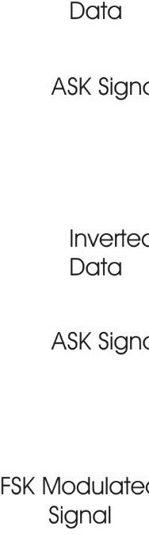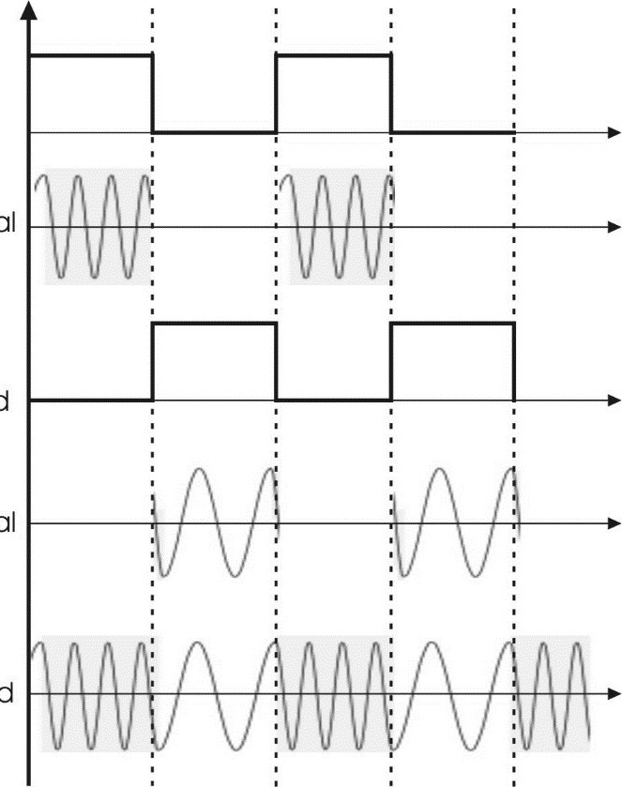

Figure 3. Generation of FSK Waveform from the sum of two ASK Waveforms

The demodulation of FSK waveform can be carried out by a phase locked loop. As known, the phase locked loop tries to 'lock' to the input frequency. It achieves this by generating corresponding output voltage to be fed to the voltage controlled oscillator, if any frequency deviation at its input is encountered. Thus the PLL detector follows the frequency changes & generates proportional output voltage. The output voltage from PLL contains the carrier components. Therefore the signal is passed through the low pass filter to remove them. The resulting wave is rounded to be used for digital data processing.

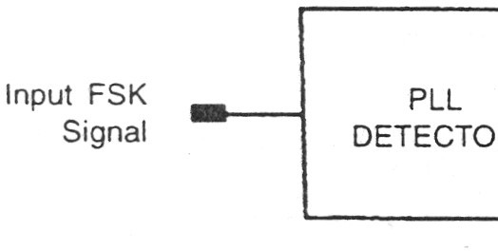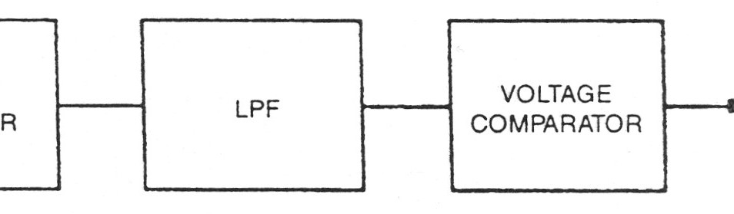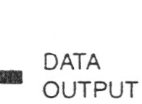

Figure 4. Frequency Shift Keying Demodulator

Also, the amplitude level may be very low due to channel attenuation. The signal is 'Shaped Up' by feeding it to the voltage comparator. The functional block diagram of FSK demodulator is shown in figure 4.

Advantages and limitations of Frequency Shift Keying Modulation

Since the amplitude change in FSK waveform does not matter, this modulation technique is very reliable even in noisy & fading channels. But there is always a price to be paid to gain that advantage.

The price in this case is widening of the required bandwidth. The bandwidth increase depends upon the two carrier frequencies used & the digital data rate. Also, for a given data, the higher the frequencies & the more

they differ from each other, the wider the required bandwidth. The bandwidth required is at least doubled than that in the ASK modulation. This means that lesser number of communication channels for given band of frequencies.

**Block Diagram:**

**Procedure:**

Step-1

1. Apply input signal (t.p. 4) to the modulation input of carrier modulation circuit (t.p. 27).
2. Apply the carrier signal (t.p. 16) from carrier generation circuit to carrier input of carrier modulation circuit (t.p. 26)
3. Observe the output (t.p. 28) on CRO screen and analyze the waveform
4. Change the carrier offset knob and observe the effect on output waveform on CRO.
5. Change the modulation offset knob and observe the effect on output waveform on CRO.
6. Change the gain knob and observe the effect on output waveform on CRO. Step-2
7. Apply input signal (t.p. 4) to the input of data inverter block (t.p. 32).
8. Apply the output of data inverter (t.p. 33) to the modulation input of carrier modulation circuit (t.p. 30).
9. Apply the carrier signal (t.p. 17) from carrier generation circuit to carrier input of carrier modulation circuit (t.p. 29)
10. Observe the output (t.p. 31) on CRO screen and analyze the waveform.
11. Change the carrier offset knob and observe the effect on output waveform on CRO.
12. Change the modulation offset knob and observe the effect on output waveform on CRO.
13. Change the gain knob and observe the effect on output waveform on CRO. Step-3
14. Apply the output of t.p 28 and t.p. 31 to the input A and input B respectively of the summing amplifier.
15. Observe the FSK waveform at output of amplifier at t.p. 36 Step-4
16. For demodulating the signal, apply the output of modulator kit t.p. 36 to the FSK demodulator kit input at t.p. 16 of trainer kit ST2157.
17. Connect the output of demodulator (t.p. 17) to low pass filter at t.p. 23.
18. Connect the output of filter t.p. 24 to the data squaring circuit input at tp. 46.
19. Set the comparator threshold by changing knob if required.
20. Observe the demodulated output at t.p. 46

**Conclusion:**

**Post Lab Exercise:**

* 1. Enlist applications of FSK signal.
  2. Compare performance of ASK and FSK.
  3. Draw block diagram for PLL.